Vincent van Gogh was born in 1853. He died of gunshot wound in 1890. He was 37 years old when he died.

He suffered from mental illness for much of his adult life.

In fact, one of his most famous paintings “A Starry Night” was a painting of his view from his window in the Asylum he was in after attacking his friend with a razor and accidentally cutting off his own ear.

Before van Gogh took to the easel, he was going to be a minister.

He was assigned to work in a poor coal-mining community. But his “unorthodox” ministry style got him in trouble with church officials. For example, He refused to bathe- because he didn’t want to be cleaner than the people he ministered to.

He tore up the sheets he had for his bed to use as bandages for people who didn’t have resources to bind up their wounds.

He eventually was rejected as minister by the Dutch church…

So Vincent became very bitter towards the church. Eventually not only leaving the ministry, but the church altogether. Understandably, he felt like the church had lost her mission. That the institution of the church had turned away from the poor- and stopped making sacrificial love their ultimate ethic.

The care that church stopped Vincent from giving to the poor and ordinary- all came out in his art. He often painted the overlooked and ordinary in an extraordinary way.

This is why I love van Gogh’s art. Because its so representative of the Kingdom of God in the way Jesus presented it. It flips things upside down. It shows the eternal in the ordinary. All the while it critiques the church for missing the Kingdom of God.

Take a look at this one called “Sower with Setting Sun” from 1888.

PIC

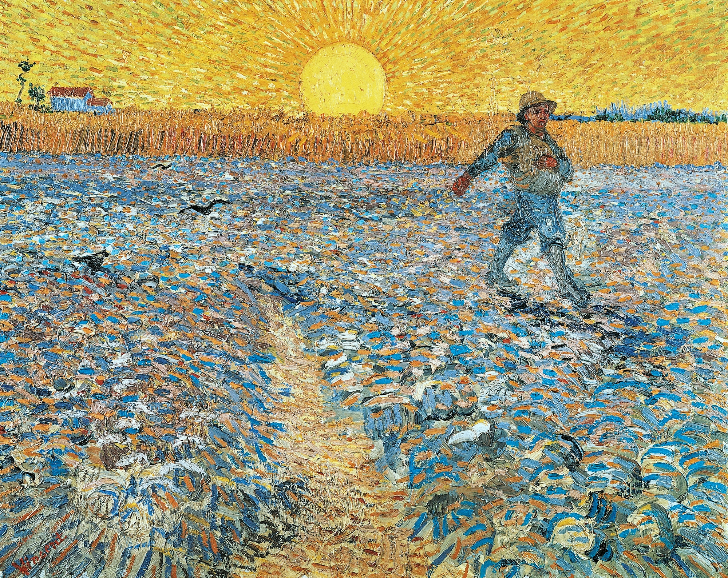

Van Gogh used the color yellow to represent the presence of God. You can see how the focal point of the piece in the large yellow sun in the center of the picture. This is a painting saturated with the presence of God. And note the only human being in it. It's a farmer. Sowing seeds in a field. God is with Him in his calling. What he does is important. It's a humble role, but it matters to God.

Now look at another version of this painting from a different perspective that van Gogh painted the same year. PIC

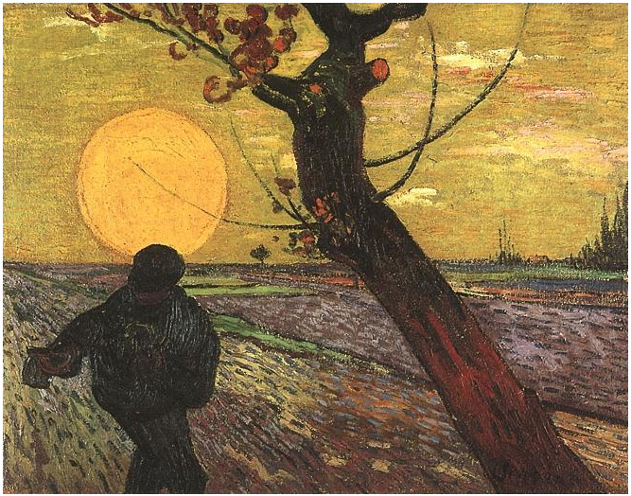

Look how the setting sun has merged with the sower. Forming the familiar corona- or halo- that is easily recognized in religious art. Showing this humble and anonymous farmer not only has having God with him…but the work he is doing is setting him apart as holy.

One last painting now- that you need both the picture and the title to really get the full impact.

This painting is entitle “At Eternity’s Gate”

Now, before I show it, when you hear someone has painted “At Eternity’s Gate”- what do you picture? Gold streets? Giant Pearls? Bright lights with people in white robes?

Maybe the door to a church or massive cathedral?

Nope. This is what “At Eternity’s Gate” looks like to van Gogh. PIC

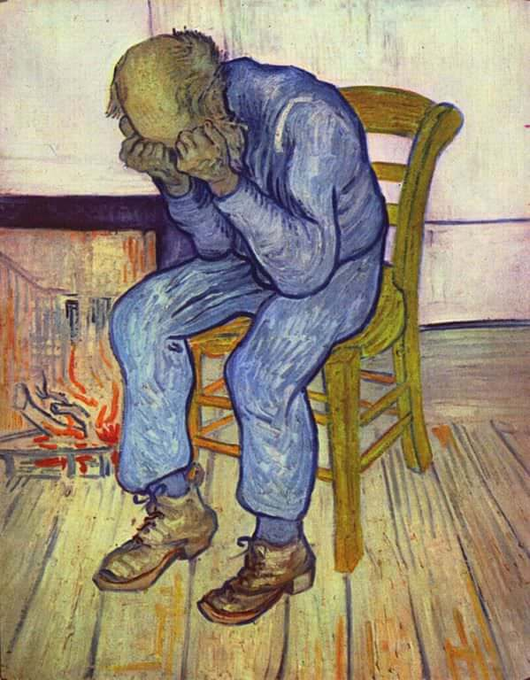

It's a older poor man in a simple chair, agonizing in prayer.

Note the fire in the background.

- “The Sower at Eternity’s Gate: Why God Wants Risky Humility for City Church in 2022”- 2 Chronicles 26 & Isaiah 6-7

It's the combination of these 3 van Gogh’s that gives us a visual for the emphasis and vision for our church in 2022- and I suppose- I hope- for the rest of our days. Today, I’m going to share with you some passages that the LORD has brought together in my mind over the last couple of months to meditate on- and I believe to set our course for this year.

Ok- these are 3 OT passages that all interact with each other, even though they are 2 different books of the bible so we got a little bit of reading, but hang with me and I’ll try to make these passages clear

2 Chronicles 26:3-21
- 3 Uzziah was sixteen years old when he became king, and he reigned fifty-two years in Jerusalem. His mother’s name was Jecoliah; she was from Jerusalem. 4 He did what was right in the Lord’s sight just as his father Amaziah had done. 5 He sought God throughout the lifetime of Zechariah, the teacher of the fear of God. During the time that he sought the Lord, God gave him success.

- 6 Uzziah went out to wage war against the Philistines, and he tore down the wall of Gath, the wall of Jabneh, and the wall of Ashdod. Then he built cities in the vicinity of Ashdod and among the Philistines. 7 God helped him against the Philistines, the Arabs that live in Gur-baal, and the Meunites. 8 The Ammonites paid tribute to Uzziah, and his fame spread as far as the entrance of Egypt, for God made him very powerful. 9 Uzziah built towers in Jerusalem at the Corner Gate, the Valley Gate, and the corner buttress, and he fortified them. 10 Since he had many cattle both in the Judean foothills and the plain, he built towers in the desert and dug many wells. And since he was a lover of the soil, he had farmers and vinedressers in the hills and in the fertile lands.

- 11 Uzziah had an army equipped for combat that went out to war by division according to their assignments, as recorded by Jeiel the court secretary and Maaseiah the officer under the authority of Hananiah, one of the king’s commanders. 12 The total number of family heads was 2,600 valiant warriors. 13 Under their authority was an army of 307,500 equipped for combat, a powerful force to help the king against the enemy. 14 Uzziah provided the entire army with shields, spears, helmets, armor, bows, and slingstones. 15 He made skillfully designed devices in Jerusalem to shoot arrows and catapult large stones for use on the towers and on the corners. So his fame spread even to distant places, for he was wondrously helped until he became strong.

- 16 But when he became strong, he grew arrogant, and it led to his own destruction. He acted unfaithfully against the Lord his God by going into the Lord’s sanctuary to burn incense on the incense altar. 17 The priest Azariah, along with eighty brave priests of the Lord, went in after him. 18 They took their stand against King Uzziah and said, “Uzziah, you have no right to offer incense to the Lord ​— ​only the consecrated priests, the descendants of Aaron, have the right to offer incense. Leave the sanctuary, for you have acted unfaithfully! You will not receive honor from the Lord God.”

19 Uzziah, with a firepan in his hand to offer incense, was enraged. But when he became enraged with the priests, in the presence of the priests in the Lord’s temple beside the altar of incense, a skin disease broke out on his forehead. 20 Then Azariah the chief priest and all the priests turned to him and saw that he was diseased on his forehead. They rushed him out of there. He himself also hurried to get out because the Lord had afflicted him. 21 So King Uzziah was diseased to the time of his death. He lived in quarantine with a serious skin disease and was excluded from access to the Lord’s temple, while his son Jotham was over the king’s household governing the people of the land.

Isaiah 6:1-13
- In the year that King Uzziah died, I saw the Lord seated on a high and lofty throne, and the hem of his robe filled the temple.
- 2 Seraphim were standing above him; they each had six wings: with two they covered their faces, with two they covered their feet, and with two they flew. 3 And one called to another:

- Holy, holy, holy is the Lord of Armies;
- his glory fills the whole earth.
- 4 The foundations of the doorways shook at the sound of their voices, and the temple was filled with smoke.

- 5 Then I said:

- Woe is me for I am ruined
- because I am a man of unclean lips
- and live among a people of unclean lips,
- and because my eyes have seen the King,
- the Lord of Armies.
- 6 Then one of the seraphim flew to me, and in his hand was a glowing coal that he had taken from the altar with tongs. 7 He touched my mouth with it and said:

- Now that this has touched your lips,
- your iniquity is removed
- and your sin is atoned for.
- 8 Then I heard the voice of the Lord asking:

- Who will I send?
- Who will go for us?
- I said:

- Here I am. Send me.
- 9 And he replied:

- Go! Say to these people:
- Keep listening, but do not understand;
- keep looking, but do not perceive.
- 10 Make the minds of these people dull;
- deafen their ears and blind their eyes;
- otherwise they might see with their eyes
- and hear with their ears,
- understand with their minds,
- turn back, and be healed.
- 11 Then I said, “Until when, Lord? ” And he replied:

- Until cities lie in ruins without inhabitants,
- houses are without people,
- the land is ruined and desolate,
- 12 and the Lord drives the people far away,
- leaving great emptiness in the land.
- 13 Though a tenth will remain in the land,
- it will be burned again.
- Like the terebinth or the oak
- that leaves a stump when felled,

the holy seed is the stump.

Isaiah 7:3-17
- 3 The Lord said to Isaiah, “Go out with your son Shear-jashub to meet Ahaz at the end of the conduit of the upper pool, by the road to the Launderer’s Field. 4 Say to him: Calm down and be quiet. Don’t be afraid or cowardly because of these two smoldering sticks, the fierce anger of Rezin and Aram, and the son of Remaliah. 5 For Aram, along with Ephraim and the son of Remaliah, has plotted harm against you. They say, 6 ‘Let’s go up against Judah, terrorize it, and conquer it for ourselves. Then we can install Tabeel’s son as king in it.’ ”

- 7 This is what the Lord God says:

- It will not happen; it will not occur.
- 8 The chief city of Aram is Damascus,
- the chief of Damascus is Rezin
- (within sixty-five years
- Ephraim will be too shattered to be a people),
- 9 the chief city of Ephraim is Samaria,
- and the chief of Samaria is the son of Remaliah.
- If you do not stand firm in your faith,
- then you will not stand at all.

- 10 Then the Lord spoke again to Ahaz: 11 “Ask for a sign from the Lord your God ​— ​it can be as deep as Sheol or as high as heaven.”

- 12 But Ahaz replied, “I will not ask. I will not test the Lord.”

13 Isaiah said, “Listen, house of David! Is it not enough for you to try the patience of men? Will you also try the patience of my God? 14 Therefore, the Lord himself will give you a sign: See, the virgin will conceive, have a son, and name him Immanuel. 15 By the time he learns to reject what is bad and choose what is good, he will be eating curds and honey. 16 For before the boy knows to reject what is bad and choose what is good, the land of the two kings you dread will be abandoned. 17 The Lord will bring on you, your people, and your father’s house such a time as has never been since Ephraim separated from Judah: He will bring the king of Assyria.”

Transition: I’ve got 3 pictures of our church today from these passages from each of the characters we just read about. Uzziah, Ahaz, and Isaiah. Each represents a different route we can take as a church. The first two- I’m recommending we not do. The third- That’s our future.

1)Pride overestimates yourself & takes foolish risks.
  - Uzziah is the perfect picture of this.
  - Notice how King Uzziah starts off.
  - V 2 Chron 26:4-5
  - First off, he’s 16 years old when he takes the crown. No pre-frontal cortex. Can’t even rent a car. It's a pretty desperate situation. How’s a 16 year old going to know how to lead a nation?

Well, that desperation has him leaning into his Father Amaziah. He watched how his Father led by doing right as YHWH led him…so he had a good model that he followed.
  - Additionally, Uzziah, when he started was seeking God, and submitting himself to the teaching of Zechariah- who taught him to fear God. That means to see God for who he is and respect him.
  - Because of this humility- knowing that he was incapable of leading without help- and having the right perspective of who God is and what God wants to do- the LORD gave him success.

  - V 2 Chron 26:10b (start at And since he was a lover…)
  - Here’s a little nod to van Gogh’s sower-
  - He was a lover of the soil and he had farmers and vinedressers in fertile lands.

  - So its military and government success yes- but he’s also re-investing in the land and in people.
  - And then the Chronicler goes on and on an about how this young kid grew up in humility to become a great King- until something shifted.

  - 2 Chron 26:15
  - He designs this war device that shoots arrows and also catapults stones- it also has a screwdriver, a can-opener, tweezers, a magnifying- glass and a little toothpick.

  - and note His fame spread to distant places.
  - Now- when I see “fame”- my first thought is “uh-oh”. Because fame is so dangerous. The spotlight- when social media starts singing your praises. When people who don’t know you think you’re great. Danger WILL ROBINSON!

  - But notice- its not necessarily his fame that is his problem. In fact- It was God that helped him achieve this fame in his successes.

  - Notice what the problem is.
  - Its when Uzziah lost sight of the God he had so long been trained to be in awe of and in service to. He started to believe his own press. He started googling his name to see what people were saying about him. He started to live his life for the red hearts and the blue thumbs.
  - He came to a place- where he was no longer weak. He was a King. And people loved his catapult.
  - And in one of the hardest hitting lines in Scripture that has long shaped my approach to life and ministry- “He was wondrously helped until he became strong.”

  - The evidence of that pride? He tries to take on roles and callings that are not his to take.

  - 2 Chron 26:16
  - In YHWH’s economy- the king and priest are separate offices- different callings. Kings are called and set apart for one thing- like governing and military leadership- Priests for doing the work of the temple and leading Israel in worship.

  - But once pride gets deep into the heart of Uzziah- he thinks he’s special. He can do anything. No rules apply to him. Its not about calling- its about HIM. He won’t have a silly priest getting in his way.
  - 26:19
  - So despite 80 priests telling him to stop- Reminding him of his role- he blows right past them in anger. Because they can’t recognize his greatness. Classic Narcissim at its ugliest.

  - Remember when Uzziah was weak? Remember when he was desperate? Remember when he listened to wise counsel? I hope you do, because Uzziah forgot.

  - 26:23
  - His legacy became not the great things he did with the Lords help- on his tombstone he was known for the disease that he inflicted on himself when he took a foolish risk.
  - He betted on himself and against YHWH.
  - He lost his fear of the LORD- believed his own press- and forgot that he was a part of God’s plan- believing instead that God was a part of his plan.

  - Ultimately- he was replaced. And remembered only for his foolishness.

- Back to 1)

  - City Church- we have lots to be proud of as a church over the last 10 ½ years. But we were wondrously helped as we have been weak. I have no desire to become strong. If God spreads our fame across the land- that's his business. By the power of the Holy Spirit, I will not be believing that press. Instead- lets keep the fear of God- the awe of him in our vision. Yes- I believe we’re going to do some great things- because the God we serve is great…but as we sow the seed of the Kingdom of God, lets stay close to eternity’s gate.
  - I want us to take risks in 2022. In fact that's going to be a theme for us this year. But not the kind of risks bathed in prided- where we lose sight of our scope and calling because we think we are more than we really are.

- Transition: Now- we’re going to jump to Isaiah 7 and look at Ahaz- who strangely has a similar problem. Its pride- but its masquerades as humility. Also known as fear- particularly fear of man.

2) Fear of man underestimates God & masquerades as humility.
  - I preached Isaiah 7 about Ahaz last month in our advent series- so I won’t spend a lot of time explaining this text…but let me give you a refresher.
  - Ahaz was the grandson of Uzziah.
  - Ahaz got wind that two kingdoms from the North were teaming up against his Kingdom- Judah in the south. He was WAAAAYYYY overmatched. But the LORD had a history of delivering his people from outside threats, especially when they were weak and overmatched. God has a thing with helping the weak.
  - Isaiah 7:2b (start at “The Heart of Ahaz”)
  - You can see the fear in this passage- the Heart of Ahaz and his people were like a forest shaking in the wind.
  - 7:4
  - The Prophet Isaiah is sent to tell Ahaz to calm down and be quiet. He is told that God plans to deliver Judah by his own strength from this outside force. He’s even told to ask God for a sign to show him this.

  - But Ahaz, because he trusts in the strength of armies more than the LORD of armies- has already struck a deal with the Assyrian King.

  - See his fear was really pride in disguise. How?
  - God is speaking to him and he thinks “I know better how to protect my Kingdom than God does.”
  - So he made a deal with this pagan King- and then..then- he masquerades his fearful pride as humility and trust in the Lord.
  - 7:12
  - When Isaiah tells him to ask the LORD for a sign- he says “OH no! I know what God says about Testing him…and because I am a holy and righteous king- I would never do such a thing.”
  - Really though, whats going on- Is that Ahaz is so afraid of this attack- he has just taken matters into his own hands. SO he doesn’t need a sign. In desperation he turned away from God- but still wants everyone to think that he is committed to God’s way.

  - He is unwilling to take a risk that God is calling him to.
  - To be calm and wait for the Lords help.
  - To trust in the unseen hand of the Lord of armies instead of what he can see in the King of Assyria and his army.

- Back to 2)
  - And so it all backfires.
  - Assyria brings destruction and oppression to Judah as the King of Assyria not only comes in and defeats the armies to the north, but also takes of Judah completely.

  - For Uzziah- it was pride that took foolish risk that was his downfall.
  - For Ahaz- it was fear of ma- and pride that was unable to value the unseen promise of God- that was his downfall. Uzziah took the wrong risk because of his pride- and Ahaz wouldn’t take the risk he was called to because of his pride.

Transition: and that leaves us with Isaiah. The picture of who God is calling our church to be in 2022 and beyond. Because…

3) True humility risks because it sees God as infinite, ourselves as limited, & obedience as success.

  - You know how many paintings Vincent van Gogh sold while he was alive?
  - One. One single painting.

  - Now- an original van Gogh can sell for hundreds of millions.
  - I wonder what Vincent thought when he died of a self-inflicted gunshot wound- which for long time was believed to be suicide, but more recent evidence has actually tilted the verdict to an accident.

  - Did he think his life was a failure?
  - Did he look at the hundreds of pieces of art he drew and painted and think- this has all been a waste?

  - While we can’t be sure what he thought- we can at least say that a lifetime of being rejected by the church- struggling as a poor artist that depended on the sponsorship and generosity of people like his brother- certainly kept in a position of weakness and poverty.

  - Which is exactly what he painted so well with a perspective of joy and closeness to God.

  - So I don’t think van Gogh looked at his life as a failure. I think he knew what his calling was…and lived it out in obedience to the LORD. I think he valued God and his creation and saw something that many others who had been blinded by a common understanding of success couldn’t see. I think van Gogh saw something that many others- because of their pride- of overestimating themselves or underestimating God- never allowed them to do.

  - I think van Gogh- in some respects is a lot like Isaiah.

  - Isaiah 6:1
  - First, notice the timestamp.
  - Isaiah gets this vision about YHWH seated on a throne. The question that comes to mind is what is a THRONE doing in the temple.
  - Temples didn’t have chairs…let alone thrones.
  - Thrones were for kings in palaces. Temples had no chairs because priests were always busy offering sacrifices and preparing for worship.

  - But this was the year that human king tried to also be a priest…and set up his throne of pride in the temple.
  - This is YHWH saying “I’m the only King who can sit down in the temple.”

  - 6:3-4
  - And notice what he is called here. The LORD of HOSTS or LORD of Armies.
  - Uzziah is dead because he thought his armies and military prowess qualified him to be on God’s level.
  - BUT YHWH is the ONLY LORD of armies.
  - He’s the only one who truly wins battles.
  - He’s sees God as infinite in his power. Infinite in his love. Infinite in all his qualities.

  - And the seraphim sing HOLY HOLY HOLY
  - Set a part.
  - And there’s smoke. Fire- always a representation of God’s presence and power. Like the color yellow in all van Gogh’s paintings.

  - 6:5
  - And now look at the humility of Isaiah.
  - I am ruined. I am a man of unclean lips.
  - I serve the people of unclean lips
  - In other words- he sees his own limitations. He can’t do everything. He is limited by his weakness. His sin. His shortfall of the glory of God.
  - And he knows this because he has seen the KING- the real king. Not King Uzziah…no- KING YHWH- the LORD of Armies

  - He has the fear of God, and by it he overcomes the fear of man.

  - 6:6-7
  - It is in this weakness- this humility that the Lord comes to help.
  - He brings his fire in the form of a coal- the holy fire of God cleanses the lips- and by extenstion- all of the unholiness of Isaiah. All of his sin is removed and atoned for.

  - Because of humility and God’s graciousness- he is marvelously helped.

  - 6:8
  - Then- a calling.
  - Who will I send- Who will go for me says YHWH.
  - Not because he NEEDS Isaiah- but because God values sowers who will work in his presence.

  - And gladly- Isaiah takes a wise risk on God.
  - Here am I send me.

  - Now at this point- we expect the rest of Isaiah’s story to be like Uzziah when he trusted the LORD. Fame to come to him. Success in everything he touches.

  - 6:9
  - But Isaiah doesn’t sell a single painting.
  - No one listens
  - At least in Isaiah’s life.

  - But you know what- neither van Gogh nor Isaiah measured success by their fame…or whether or not people responded the way they wanted them to.

  - Instead- they measured their success by obedience to God’s calling.
  - Did God call me to do this? YES. Then I am made strong in my weakness. I have finished the race. I am with God and he is with me…and that is a success.

  - City Church- I want you to see us in this vision- and in these van Gogh paintings.

  - ETERNITYS GATE Pic
  - This is Isaiah 6- it is the key to our strength. The fire of God near us. Desperate in prayer. Humble- not believing our own press or looking for

  - Sower 1 (non Corona) Pic
  - We have a calling. In all our humble ordinary lives to spread the word and love and presence of God whereve we Go. And like van Gogh’s sun in the sky…so the presence of God is with us as we joyfully obey…taking a risk on God’s calling. Not giving into prideful fear where we underestimate God’s power and love…nor giving into prideful overestimation of ourselves.

  - Sower 2 (Corona) pic
  - And as we do this we become holy. We become attractive. Our lives become a magnet for the Kingdom of God- inviting others in as we sow seeds in humility, and generosity, and hospitality.

  - And the only way this is possible- is if we know the God who went through these pictures in reverse order.

  - Jesus started here. He is Holy Set Apart GOD the Son. Eternal. Creating the World. All thrings are created through him and for him.

  - Sower 1 pic
  - And yet, he descended.
  - Though he was limitless- he humbled himself becoming a man. Living in the presence of his Father- but did not consider divinity a thing to be held onto. Rather to serve us… he became a common sower of the seed of the Kindgom of God.

  - ETERNITYS GATE pic
  - And on the cross, he descended all the way to the place of death.
  - He cried out from the cross “My God, My God why have you forsaken me!”

  - He was shamed, spit upon, beaten, and crucified.
  - And do you know why?

  - Because he was doing what that firey coal did for Isaiah in Isaiah’s vision.
  - He was atoning for our sin.
  - Jesus is how the weak become strong.

  - On the cross- he was bearing the punishment for our sin.
  - He was taking on the shame of our prideful overestimation of ourselves and underestimation of God.

  - Then in Jesus resurrection- he overcame our limitations- and now offers the fire and the presence of his Holy Spirit to us.

  - Sower 1 (non corona pic)
  - SO that we are just like this sower.
  - Joyfully taking God’s presence with us we live into our calling…taking a risk on the unseen over the seen.

Back to 3)

City Church- here is what our elders are calling us to in 2022.

True humility that will risks wisely because we see God as infinite, ourselves as limited, and obedience as success.

I don’t know what this will mean for each of you, but for me, it means a kind of vulnerability because I’m going to step into some areas that I think I’m called to, but fear of man has held me back.

But knowing that success is not wrapped up in how many people listen to us…or how much money we make…but our success is wrapped up in following Jesus our savior into where he calls us to love and to sow the seed of God’s Kingdom.

So city church. Fear has expired because Jesus put an expiration date on sin and death. 2022 will not be the year of Humble Risk. It will be the year we start decades of humble risk.

You can’t get there without Jesus. You can’t get there without your sin atoned for. Lets start there in 2022. Have you received Jesus’ forgiveness and atonement. If you start trying to pursue your calling without that- your pride and fear will overtake you. So will you repent and trust him today?

